Topic 10
More Summary Measures and Graphs

Five Number Summary (FNS)
- Minimum
- 1st Quartile
- Median (2nd Quartile)
- 3nd Quartile
- Maximum

Example {1,3,5,4,3,8,7,6,0,6,8,5,3,5,3,4,8,7}
Ordered, {0,1,3,3,3,3,4,4,5,5,5,6,6,7,7,8,8}
Min = 0, Max=8
Next find the median. n=17 is odd, so find median using (n+1)/2 method
(n+1)/2=9, and the 9th value of the ordered set = 5.
Median is 5.
On either side of 5 are eight values. The median of those values are the average of values 4 and 5 in each set. The median of the first set is Q1, and that turns out to be (3+3)/2=3, and the median of the second set is (6+7)/2=6.5, which is Q3. We can now build our FNS table

Min | Q1 | Med | Q3 | Max
0 | 3 | 5 | 6.5 | 8

Boxplot (Box and Whisker)

- “Box” is middle 50% of data (Q1 to Q3) with median line
- Whiskers extend to min and max
- No outliers
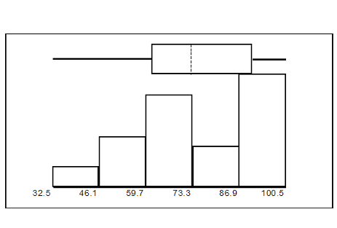
(Modified) Box and Whisker Plot (or modified boxplot)
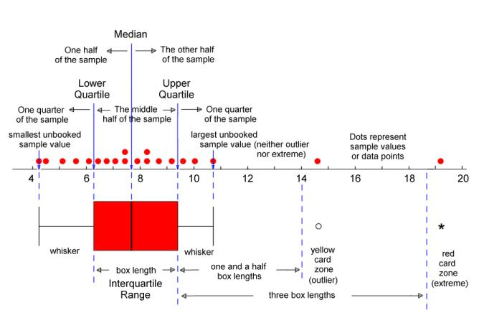

Modified Boxplot
- Box is the same
- Whiskers only extend to the last data point
  - <= Q1 - 1.5*IRQ
  - >= Q1 + 1.5*IRQ
- After that, they are labeled as outliers
- Sometimes, label outliers > 3*IRQ differently

The boxplot is an extremely useful graphic for viewing 2 dimensional data where
- One dimension is categorical, the other is quantitative
- We don’t know the parameters or arithmetic measures of the data
- We want a graphic representation of FNS
- The data distribution is asymmetric or funky in some other way

Recall that Ordinal can be treated as either quantitative or categorical, depending on what you want to show.

