PSY 325, Sensation and Perception, with Short-Term Study in Paris
Fact Sheet

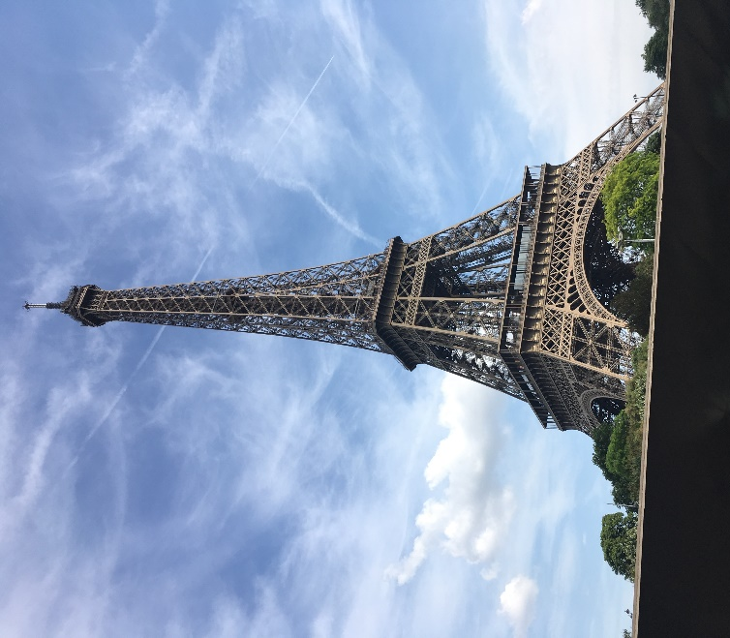
PSY 325, Sensation and Perception, will be taught in Spring 2018, with an 8-day trip in May 2018 (shortly following graduation). Note: the trip is an integral part of the course. Anyone taking the course is also going on the trip.

In the course, we’ll learn about the way that our senses work from both a psychological and a physiological perspective. We’ll think about how we take in information from the outside world (in health and in sickness), and integrate it with our private world and personal memories. Then, we’ll travel to Paris, where we will excite our senses by exploring the city around us. Because many students will not speak French, they will be forced to attend to their senses (rather than linguistic representations of someone else’s experiences) in order to navigate their environment.

Course features specific to travel:
- Getting ready for Paris: an introduction to international travel and navigating the city
- How not to be “the ugly American”: An introduction to some basic French phrases and fundamental French manners
- Packing for the journey

The trip includes the following:
- Admissions to major museums, including the Louvre, the Musée d’Orsay (Impressionist Museum), and others.
- Admissions to attractions, such as an open bus tour, chocolate tasting, and wine tasting.
- Walking tours of central Paris, including Notre Dame, Sainte-Chapelle, the Eiffel Tower, Arc de Triomphe, Sacre Coeur and Montmartre, the Luxembourg Garden, and other sites
- A tour of the Paris Opera House
- Evensong at Notre Dame
- Visit to the Studio Parfums, to create a fragrance
- Welcome and farewell dinners
- Cruise on the Seine River, which runs through the heart of Paris
- 7 nights in a Paris hotel (double rooms), including breakfast
- Round-trip airfare from Syracuse to Paris
- And more!

Nuts and bolts:
- The total trip cost will be determined by the number of students going, the exchange rate, and many other factors. Currently the estimated cost for 15-20 students is $3897.
- This fall, students can apply for a $600 grant toward the trip cost from the Harriet O’Leary Fund (Contact the Office of the Dean of Arts and Sciences).
- Students may also apply for a scholarship from The Edward R. '68 and Susan Mahoney '69 Loos Endowment for Experiential Learning and Travel (Contact the Office of the Dean of Arts and Sciences) to help defray the cost of the trip.
- Application form; deposit ($500 needs to be given to the Bursar by 30 Nov., 2017)
- Costs are billed to students in the Spring Tuition and are due at the beginning of the spring semester.
- Other considerations: by the first day of the spring semester, students must have a passport valid for at least six months beyond our return date, or provide proof that a passport application was submitted over winter break.
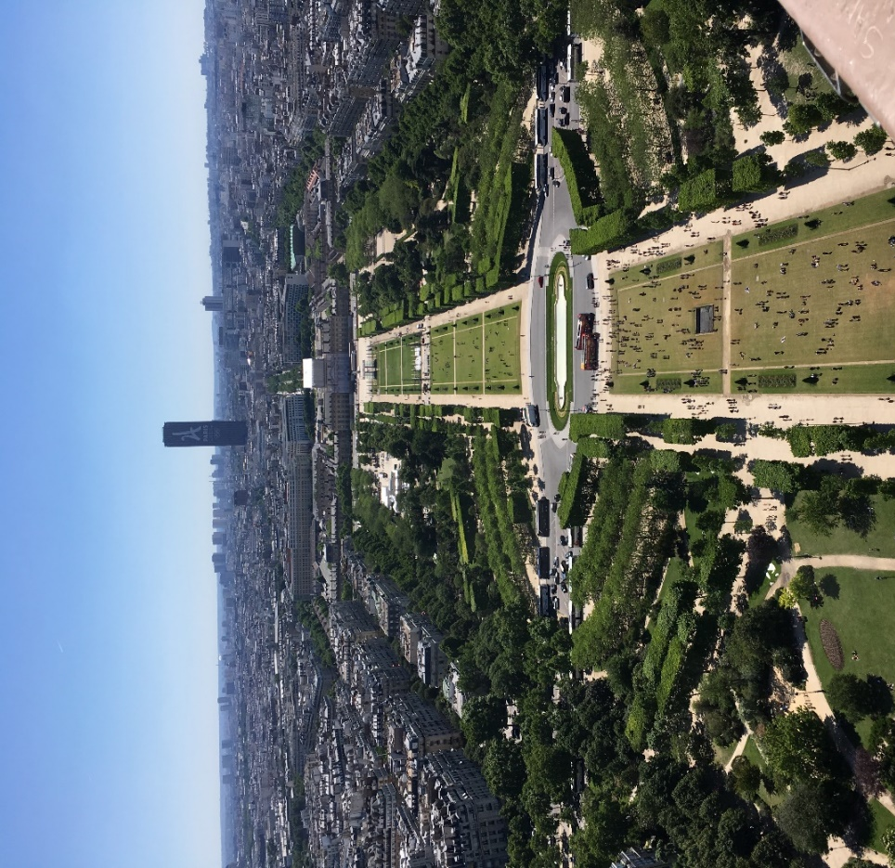
Applications for the course will be due on Nov. 30, 2017.

Theresa L. White
Professor, Psychology Department
whitetl@lemoyne.edu
RH 224
(315) 445-4340

Paris, as seen from the Eiffel Tower

