**Main Theme**: Is momentum conserved in a collision?

Momentum, **p** = mass times velocity = m**v**. Momentum is a vector quantity so you must add **p** components

Total momentum before collision = Total momentum after collision. You are proving this in the lab.

Elastic collision: Total Kinetic Energy before collision = Total Kinetic After collision

Inelastic collision: Total Kinetic Energy before collision is LESS THAN Total Kinetic After collision (“sticky collision”)

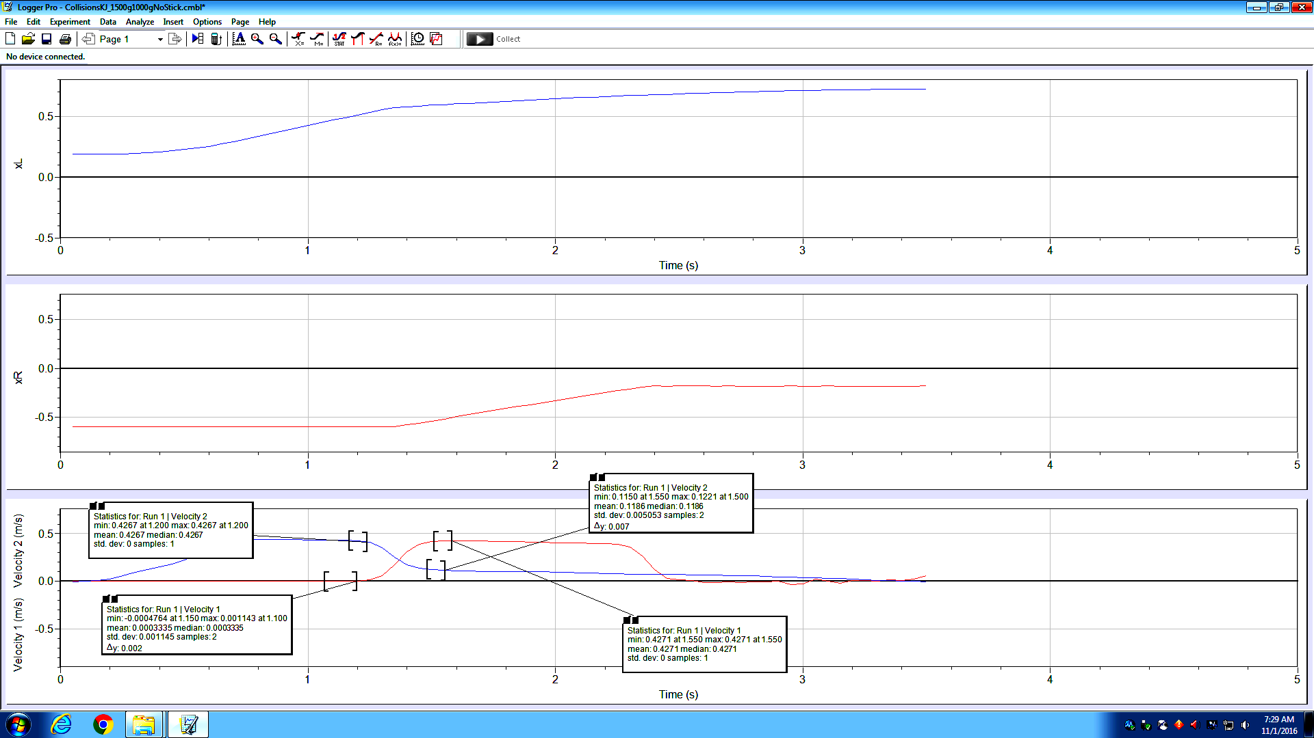

Velocity of a cart is positive when it is moving to-the-right

Position of RIGHT cart increases when moving to-the-right

Position of left cart increases when moving to-the-right

This PC /www/CourseInformation/SC123/Table1

The **velocity** of a cart is **negative** when the cart is moving **to-the-left**.

Use Dollar signs “$” before the letter in the Excel spreadsheet formulas to *freeze* the column: =$B7*$D7

“DIG1” input is the RIGHT cart. “DIG2” is the left cart.

The %Change in KE indicates the elasticity of the collision. %Change in KE will NOT be near zero for all runs.

**Activity #1 – EMPTY Left cart moves right and collides with stationary RIGHT cart with 0.5kg on it.**

**Use Magnetic carts**: Left cart is EMPTY, right cart has 0.5kg on it. The mass of a Black Rectangular bar = 0.5kg

**Total mass of left cart is about 0.5kg. Total mass of RIGHT cart is about 1kg which is mass of cart + one full bar**

* 1. – NO NEED TO MASS CARTS – mass should be written on the cart. One rectangular black bar = 0.5kg
  2. – Put ONE 0.5kg on RIGHT CART ONLY: Total mass of RIGHT cart = mass of cart + 0.5kg

**1.10** – To ZERO the motion sensors go to the EXPERIMENT tab then select Zero when one cart is in the middle

**1.11** – only change the BOTTOM graph from displacement to velocity – Click the y-axis label then “MORE” then Check Velocity 1 and Velocity 2. Uncheck Position 1 and Position 2.

Momentum change should be about +/-5%. KE change may be larger (10% or more)

**Activity #2 – One Magnetic Cart (collision cart) and One Cart with Plunger (dynamic cart)**

**2.2** –LEFT CART IS EMPTY. RIGHT CART has 1 rectangular black bar on it.

Mass of Left cart is about 0.5kg and Mass of Right Cart is about 1kg. ONLY RIGHT CART has additional 0.5kg on it.

The Velcro should keep the cars stuck together after they collide

**Activity #3**

|  |  |  |
| --- | --- | --- |
| Activity | Mass | Conditions |
| 3.1 | Cart 1 empty  Cart2 + 1 bar | Cart 2 (RIGHT) moving slowly to the right, Cart 1 (left) and moving faster to the right collides and sticks with Velcro to Cart 2 |
| 3.2 | Cart 1 empty  Cart 2 + 1 bar | Cart 1 stationary. Cart 2 (RIGHT) moving LEFT sticks with Velcro to Cart 1 |
| 3.3 | Cart1 empty  Cart2 + 1 bar | Explosion: Put Tape over the Velcro. Cart 1 and Cart 2 initially together. Explode apart |

Oct 30 2024.